Creating a storage account

In the next chapter we are going to see how to use ARM templates to create a virtual machine. The storage account will be used to store the hard disks for the virtual machine.

Please ensure that you use the same storage account name in the ARM template in place of diskstore2070. Please view the next Lab and the resource attached to that chapter to see whether to replace the name of the storage account.

Step 1 ) Go to storage accounts and add a new storage account

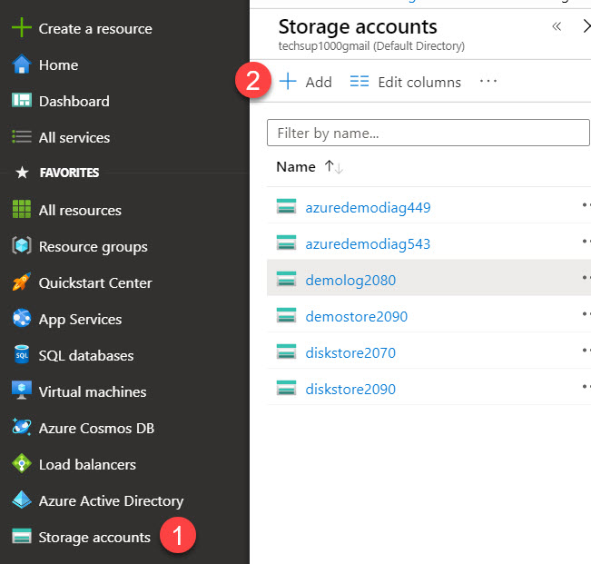

2) Enter the following details in the screen for the properties of the storage account

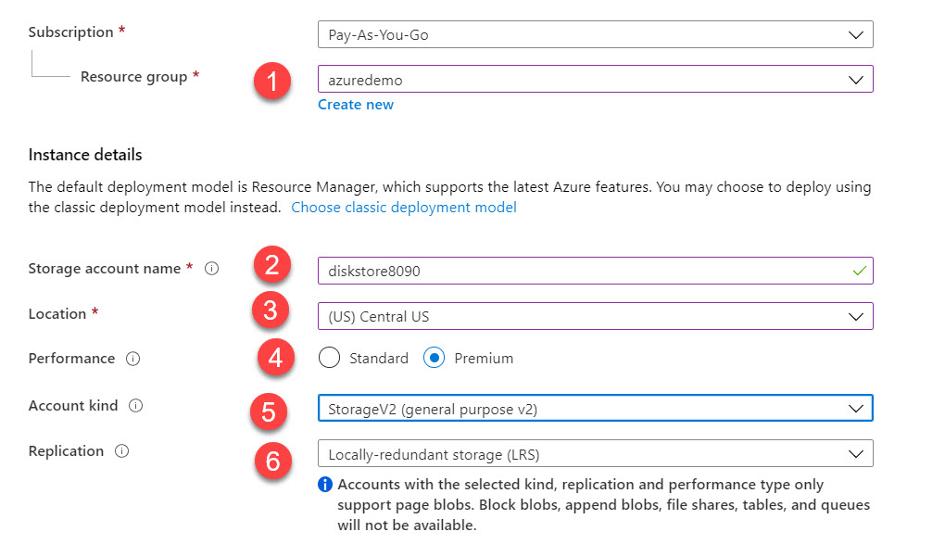

1. Choose the resource group
2. Give a unique name for the storage account
3. Ensure the location of the storage account is the same as that of the virtual machine you are going to create using the ARM template
4. Mark the Performance as Premium
5. Mark the Account kind as StorageV2
6. Mark the Replication as LRS

Step 3) You can go directly to Review and Create and then go ahead and create the storage account